Tab 1

Technical Architecture Document

HBnB Project
1. Introduction
1.1 Purpose of the document
This document provides a complete technical plan for the HBnB project. It includes the following diagrams:
- High-Level Package Diagram
- Detailed Class Diagram for the Business Logic Layer
- Sequence Diagrams for API Calls
The purpose of this document is to:
- Serve as a reference guide during implementation
- Clarify architectural decisions
- Ensure consistency across development phases
- Provide a shared understanding of system structure and interactions

1.2 Project Overview
HBnB is a web-based application inspired by rental platforms such as Airbnb. It allows users to:
- Register and manage accounts
- Create and manage property listings
- Book places
- Leave reviews
The system follows a layered architecture to ensure modularity, maintainability, and scalability.

2. High-Level Architecture
2.1 Overview
The system is organized using a layered architecture pattern combined with the Facade design pattern.
Main Layers:
- Presentation Layer (API / Controllers)
- Business Logic Layer
- Persistence Layer (Database Access)

2.2 High-Level Package Diagram
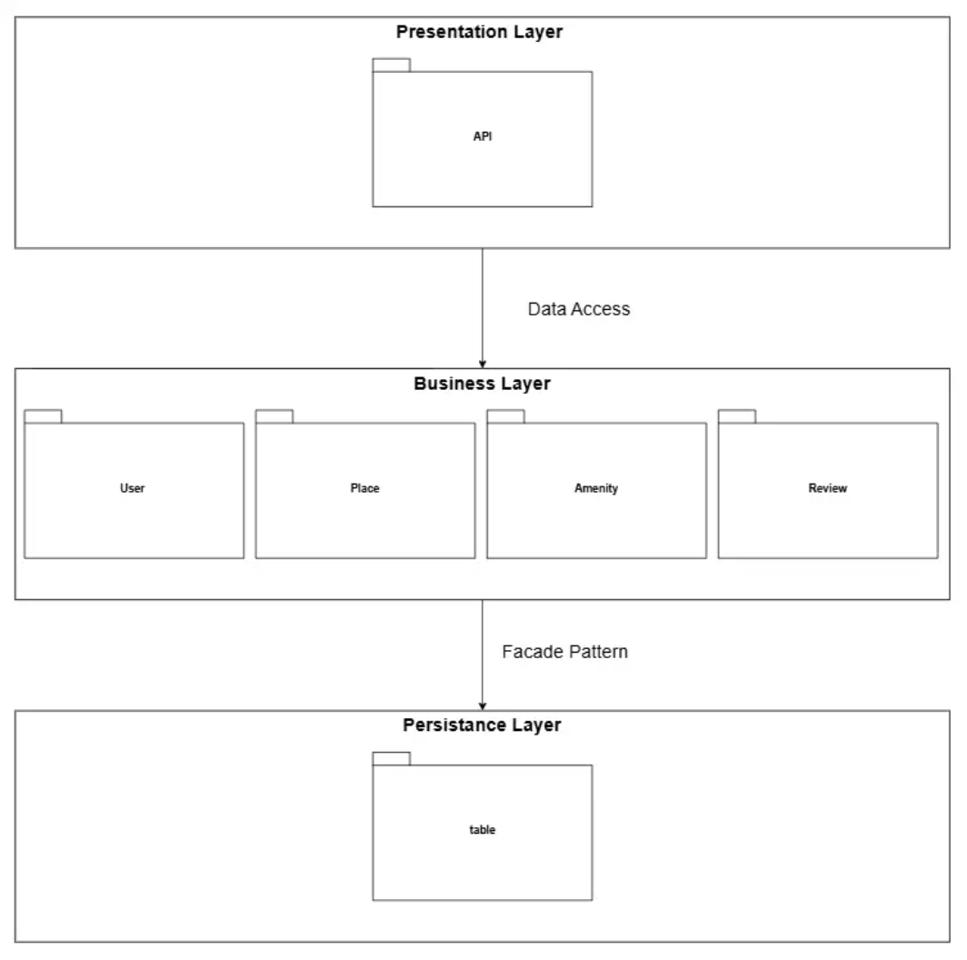

Purpose of the Diagram
This diagram illustrates the global structure of the application and how the main packages interact with each other.

2.3 Architectural Design Decisions

Layered Architecture
The system is divided into layers to ensure:
- Separation of concerns
- Loose coupling between components
- Easier testing and maintenance
Each layer has a clearly defined responsibility:
Layer | Responsibility
Presentation | Handles HTTP requests and responses
Business Logic | Implements application rules and core logic
Persistence | Manages database interactions

Facade Pattern
A Facade class is used in the Business Logic layer to:
- Provide a simplified interface to complex subsystem logic
- Reduce direct dependencies between the Presentation and Business layers
- Centralize orchestration of operations
This improves maintainability and encapsulation.

3. Business Logic Layer

3.1 Overview
The Business Logic layer contains the core entities and rules of the HBnB application.
3.2 Detailed Class Diagram
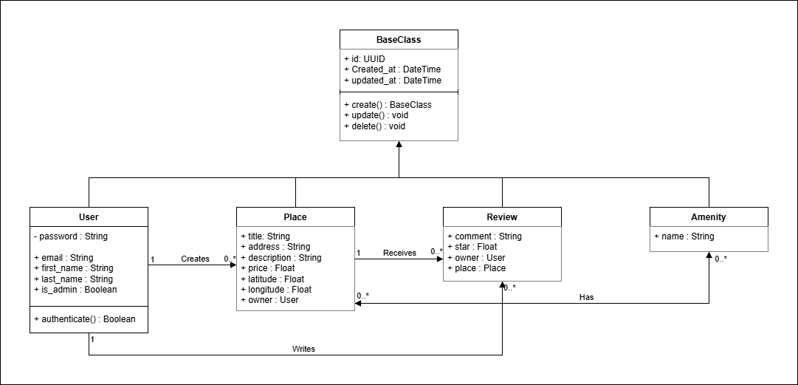

3.3 Main Entities
Typical entities in HBnB include:

BaseClass
Purpose
BaseClass is an abstract parent class that provides common attributes and behaviors shared across all entities.
Attributes
- id
- created_at
- updated_at
Responsibilities
- Ensure all entities have a unique identifier
- Track creation and modification timestamps
- Promote code reuse and consistency
Design Rationale
Using a BaseClass:
Avoids duplication of common fields
- Enforces a consistent structure across all entities
- Simplifies future maintenance
- Improves scalability
- All core entities inherit from BaseClass.

User
Represents a platform user.

Inherits From:
BaseClass
Attributes:
- id
- email
- password
- first_name
- last_name
- is_admin
Responsibilities:
- Register and authenticate
- Create places
- Leave reviews

Place
Represents a property listed for rental.

Inherits From:
BaseClass
Attributes:
- id
- title
- description
- price
- owner_id
Relationships:
- Belongs to one User (owner)
- Can have multiple Reviews

Review
Represents feedback left by a user on a place.
Inherits From:
BaseClass
Attributes:
- text
- rating
- user_id
- place_id

Relationships:
- Associated with one User
- Associated with one Place

Amenity
Represents a feature or service available in a place.
Examples:
- WiFi
- Swimming Pool
- Parking
- Air Conditioning
Inherits From:
BaseClass
Attributes:
- name
Relationships:
- Many-to-many relationship with Place
- A place can have multiple amenities, and the same amenity can belong to multiple places.
3.4 Relationships and Design Rationale
One User → Many Places
One User → Many Reviews
One Place → Many Reviews
One Place ↔ Many Amenities (Many-to-Many)
All entities inherit from BaseClass

Encapsulation
Business rules are implemented within the entities or service classes to:
- Prevent invalid data
- Enforce constraints (e.g., rating range)
- Maintain integrity

Validation Strategy
Input validation is handled at:
- Presentation layer (basic format validation)
- Business layer (rule enforcement)
This ensures both usability and data integrity.

4. API Interaction Flow

4.1 Overview
The API interaction is modeled using Sequence Diagrams to illustrate the dynamic behavior of the system.
These diagrams describe:
- Request flow
- Object interactions
- Method invocations
- Data returned

4.2 Example 1: User Registration

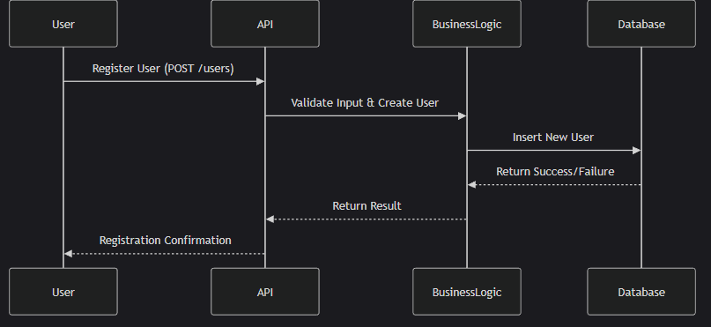
- Client sends POST request to /user
Controller receives request
- Controller calls Facade
- Facade validates data
- Business layer creates User object
- Persistence layer stores User
- Response returned to client

4.3 Example 2: Place Creation

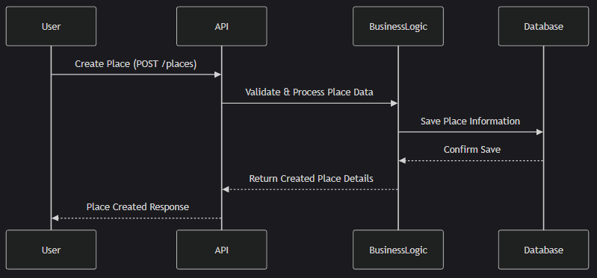
- Client sends POST request to /place
- Authentication is verified
- Controller calls Facade
- Facade creates Place object
- Place saved in database
- Success response returned

4.4 Example 3: Review Submission

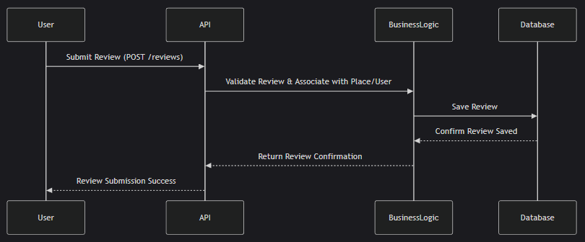
- Client sends POST request to /reviews
- System verifies:
  - User exists
  - Place exists
- Business rules validated
- Review object created
- Review persisted
- Response returned

5. How Everything Fits Together
The system works as follows:
- The client interacts with the API.
- The Presentation Layer handles the HTTP request.
- The request is forwarded to the Facade.
- The Facade orchestrates business logic.
- Entities enforce rules and constraints.
- The persistence layer manages database operations.
- The response is returned to the client.
This architecture ensures:
- Modularity
- Clear separation of responsibilities
- Scalability
- Testability

6. Conclusion
This document provides a comprehensive overview of the HBnB system architecture and design.
It includes:
- Structural architecture (Package Diagram)
- Business logic modeling (Class Diagram)
- Behavioral interactions (Sequence Diagrams)
The architecture is designed to be:
- Maintainable
- Scalable
- Secure
- Easy to extend
This technical blueprint serves as a reference throughout implementation and future evolution of the system.

